**Unit 9**

**Step 1: Reflection**

**Which existing websites out there most inspired your web site design thus far?**

There are leading design leading groups that i feel inspired by. I think that colour and unstructured layout call attention and could engage visitors if developed properly.

<http://www.frogdesign.com/>

<http://www.ideo.com>

http://[www.ideum.com](http://www.ideum.com)

**Which parts of the design are you most proud of?**

I think i manage to adapt the design to every screen size offering the visitor a good user experience whithout creating interaction friction and by allowing the images to be an intuitive way to navigate the site.

**What struggles did you encounter in your design process?**

Traslating the wireframes and mockups to the coding canvas was a challenge for me. To interpretate in code the elements and spaces and to be able to provide consistentcy across all the different screen sizes

**Which struggles did you encounter during page development?**

I am still struggling with the syntax of codes and combining them to obtain the interactions and behaviors that i have projected for each instance of use. Towards creating a cohesive design would need more experimentation with the mix of codes, styles and scripts.

**What did you learn from making your project responsive?**

I learnt to think deeper on the wide diversity instances of use when users might be interacting, exploring the sites and how the layout might help users to accomplish thier objectives and fulfill their desires and expectations. The big screen that we all are used to gives a lot of advantages because of its size and the more settle and calm context of use while mobile its more challenging due to the wide variety of agents that influence memory and perception.

**Step 1: Reflection**

**Group 1**

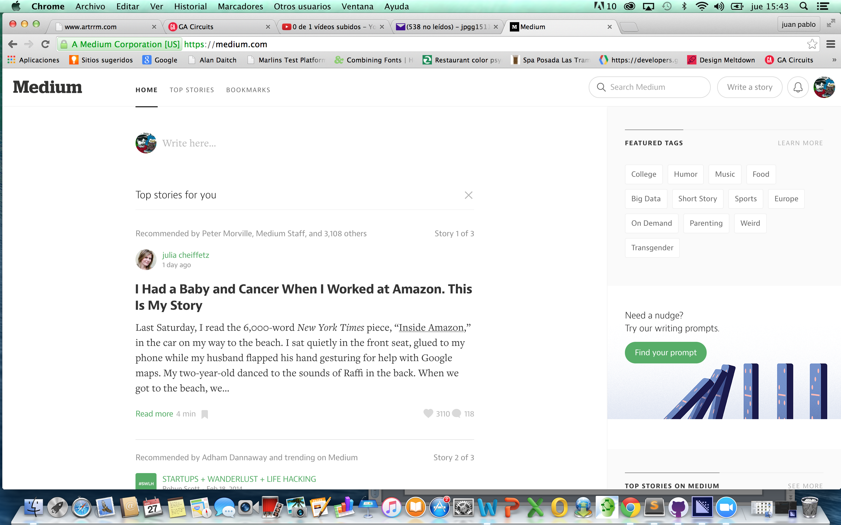https://medium.com/

In Medium is clear that content is king, the audience is interested on the stories and by providing the information well structured hierarchically, users can navigate the page in an intuitive way.

The layout of the page is alligned properly and it doesn´t loose its balance when reducing the screen size.

No matter the size of the screen, important features and input controls are accesible for the users in every instance.

|  |  |
| --- | --- |
|  |  |

Typefaces choosen make the text rich but at the same time easy to read and legible.

The weight of elements within the page is balanced with the amount of white space and by the aside column which hides on mobile version giving focus to the headers and subheaders that give enought information to the audience of the page guiding them to get deeper only on those contents that might be more relevant to them.

The use of color is controlled and i think it should give a bit more contrast to highlight a bit more the autor of the stories published.

**Group 2**

[www.mimarch.net](http://www.mimarch.net)

This page shows a saturation of information, contrasting colours on some navigation elements which behaviour and appearance are not consistent.

There is not enought white space to balance and create a flow through the content which is spread all over the page whithout following an alignment that would structure the layout to guide the user.

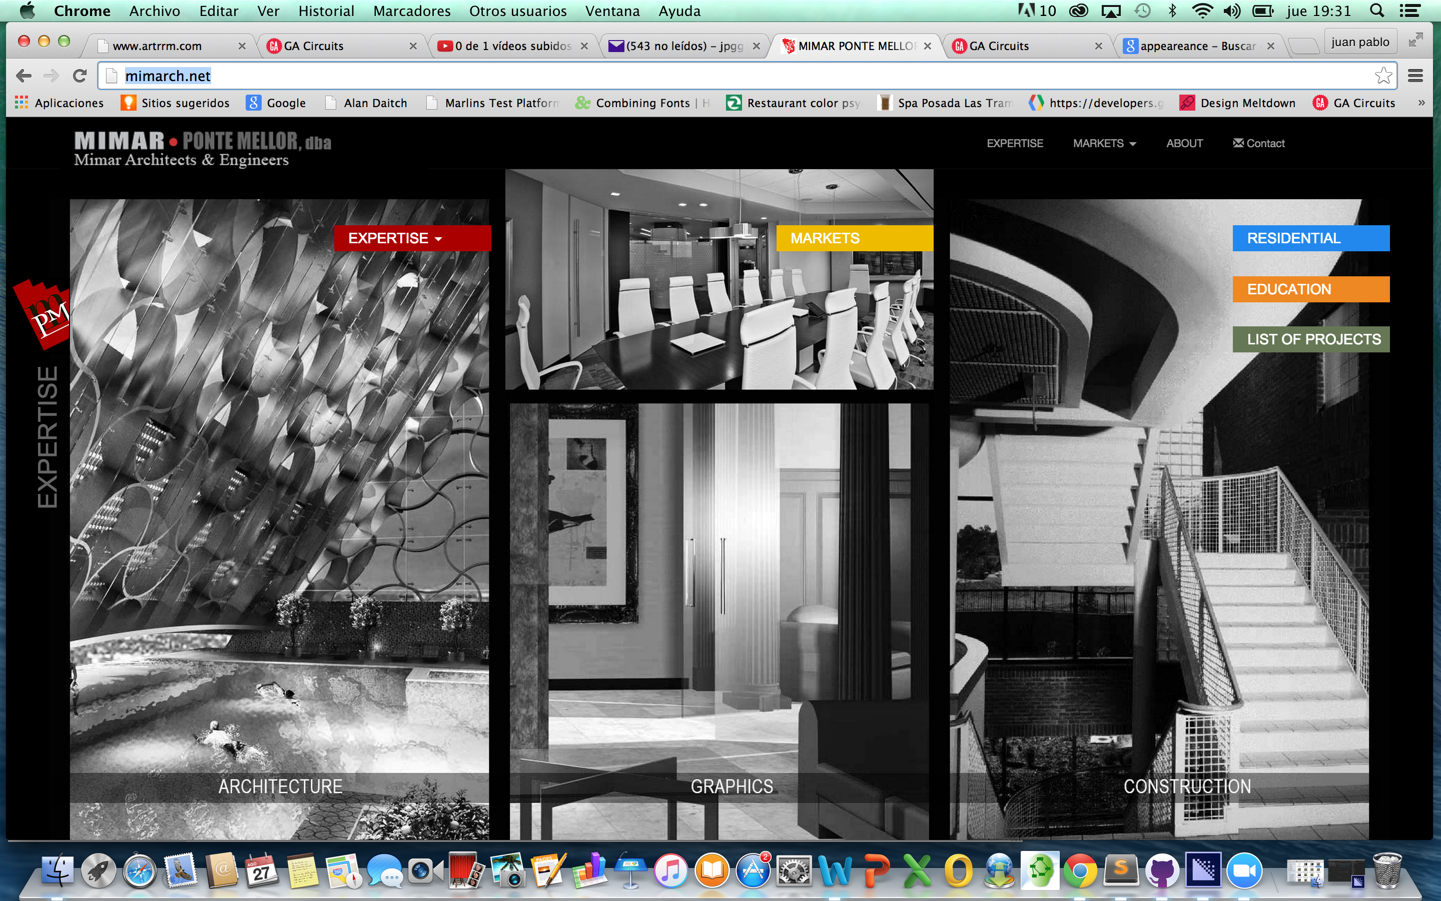

When whatching at it in smaller screens, the whole amount of the page just compress to fit the screen.

The vast amount of information on mobile context do not support memory and sensorial constraints of the users.

|  |  |
| --- | --- |
|  |  |

The sections at the bottom of the page, the links in the first two underline when hover and in the last two section, it turns yellow. The last section the yellow color is not contrasting enought against the background.

Typefaces are easy to read but in mobile context some areas of text are not contrasting enough against the background which means that in some poor light conditions nor in extreme light conditions when the sun hits the screen the user will have troubles to read.